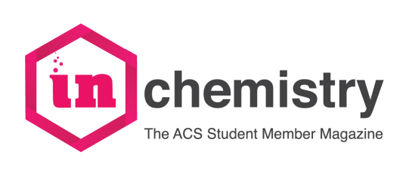
Print Edition Notice Rates

Place your graduate school notice or other announcements in inChemistry magazine. Ad rates are per insertion in one print issue. To advertise online, visit inchemistry.acs.org.

Representative Name
Department
University/College
Mailing Address
City/State/ZIP
Phone |  | Fax
E-mail |  | URL

2017-2018 Issue |  | Space Reservation Deadline | Artwork Deadline
Fall 2017 (October) |  | August 20, 2017 | September 10, 2017
Spring 2018 (March) |  | December 5, 2017 | January 10, 2017
Save $300 on advertising when you purchase booth space at the Student Networking with Grad School Recruiters Event. Contact Blake Aronson (202-872-6108, b_aronson@acs.org) for more details.
Pricing for Full Color Notice(s)
Frequency of Notices | 1 Page | ½ Page | Preferred Issue(s)
1 Issue | $1,646 | $1,236
2 Issues | $2,701 (total) | $1,961 (total)

Method of payment
Payments will be processed the month the magazine is published, unless otherwise requested.
Visa/Master Card | Card Number
American Express | Expiration Date
 | Signature
 | Cardholder Name

Please return this form to Natasha Bruceb by email: n_bruce@acs.org. If you are paying by check, please mail your check and a copy of this form to: Natasha Bruce, inChemistry Magazine, American Chemical Society, 1155 Sixteenth Street, NW, Washington, DC 20036 Questions? Call (800) 227-5558, ext. 4388. E-mail: n_bruce@acs.org.

American Chemical Society l 1155 Sixteenth Street NW l Washington, DC 20036 l 800-227-5558

